<https://tpchd.org/healthy-homes/outdoor-air-quality/idle-free-253/>

[Home](https://tpchd.org/) » [Healthy Homes](https://tpchd.org/healthy-homes/) » [Outdoor Air Quality](https://tpchd.org/healthy-homes/outdoor-air-quality/) » **Idle Free 253**

**Idle Free 253**





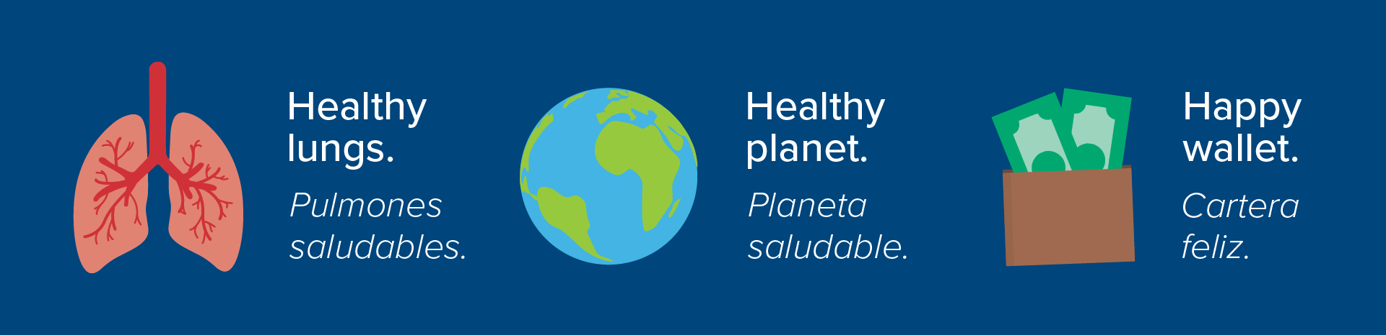

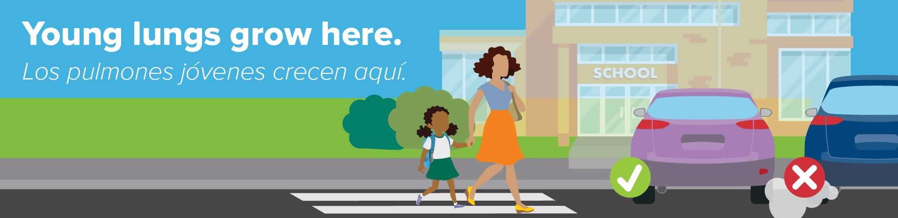











**Help keep our children healthy. Turn off your engine.**

When you keep your engine running, your vehicle creates harmful chemicals and wastes fuel. Idling fumes can cause serious diseases like asthma, heart disease, chronic bronchitis and cancer.1

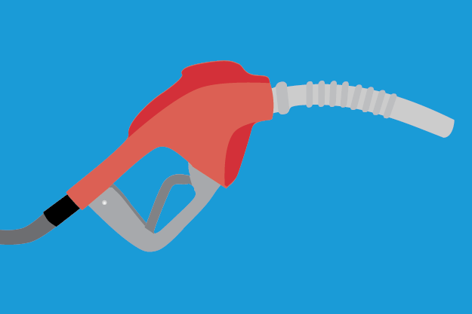

**Save fuel. Save money.**

* If you idle more than 10 seconds, you waste gas.1
* It takes less gas to restart your engine than to idle for 10 seconds or longer.1
* Idling 15 minutes a day costs you $300 per year. 1
* Idling burns up oil. The more you idle, the more frequent your car will need an oil change.1



**Protect the planet.**

* Idling cars release harmful chemicals, gasses and pollutants into the environment.2
* These emissions contribute to regional haze and global climate change.2
* For every 10 minutes your engine is off, you’ll prevent 1 pound of carbon dioxide.1
* Every gallon of gas burned produces more than 20 pounds of greenhouse gases.2



**Keep kids healthy and safe.**

* When you sit in an idling car, you breathe in exhaust that leaks into the car cabin.1
* Children’s lungs are still developing. They inhale more air per pound of body weight than adults.3
* Cars and buses idling outside a school, make it hard for students to hear moving cars.4
* Breathing exhaust fumes can damage brain cells and may be linked to autism.5

[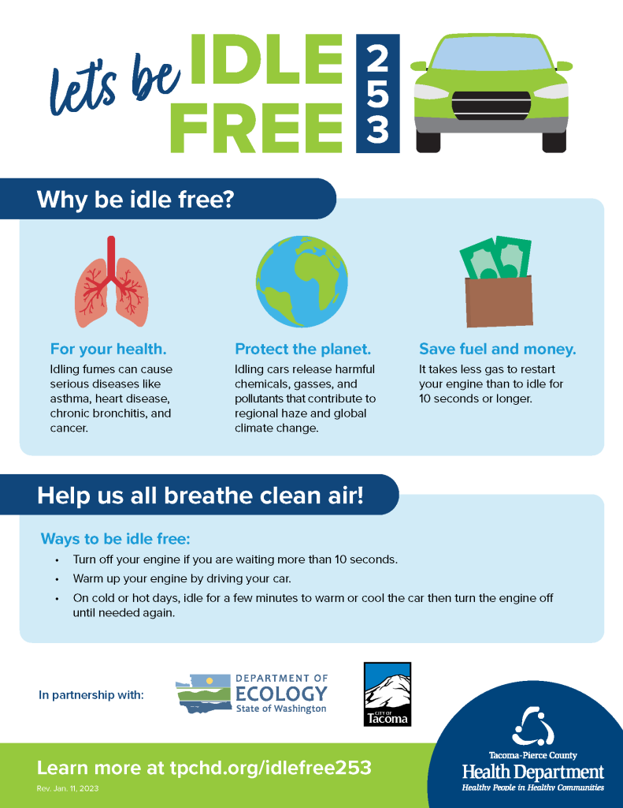](https://tpchd.org/wp-content/uploads/2023/12/Lets-be-Idle-Free-253.pdf)

**Download idling facts and ways to be Idle Free 253.**

Available in [English](https://tpchd.org/wp-content/uploads/2023/12/Lets-be-Idle-Free-253.pdf) | [Español (Spanish)](https://tpchd.org/wp-content/uploads/2023/12/Lets-be-Idle-Free-253-Spanish.pdf) | [អក្សរខ្មែរ (Khmer)](https://tpchd.org/wp-content/uploads/2023/12/Lets-be-Idle-Free-253-Khmer.pdf) | [ພາສາລາວ (Lao)](https://tpchd.org/wp-content/uploads/2023/12/Lets-be-Idle-Free-253-Lao.pdf" \t "_blank) |[Русский (Russian)](https://tpchd.org/wp-content/uploads/2023/12/Lets-be-Idle-Free-253-Russian.pdf" \t "_blank) | [Gagana fa’a Samoa (Samoan)](https://tpchd.org/wp-content/uploads/2023/12/Lets-be-Idle-Free-253-Samoan.pdf) | [Українська (Ukrainian)](https://tpchd.org/wp-content/uploads/2023/12/Lets-be-Idle-Free-253-Ukrainian.pdf) | [Tiếng Việt (Vietnamese)](https://tpchd.org/wp-content/uploads/2023/12/Lets-be-Idle-Free-253-Vietnamese.pdf).

**Ways to be idle free while you wait**

**When it’s cold outside.**

* Keep blankets in your car.
* Warm up your engine by driving it, not idling.
* Turn on the car for a few minutes to warm up, then turn it off.

**When it’s hot outside.**

* Open the windows.
* Park you car and go inside a store or building with air conditioning.
* Turn on the the car for a few minutes to cool it off, then turn it off.

**Questions? Contact us!**

Contact Angee Moore at [amoore@tpchd.org](mailto:amoore@tpchd.org) or (253) 355-8308.

**Resources**

* [It’s your turn, turn it off](https://iturnitoff.com/#/savings)—Pledge now to end unnecessary idling.
* [Walking School Bus Guidebook](https://cms.cityoftacoma.org/publicworks/saferoutes/SRTSWalkingSchoolBus.pdf)—Start a walking bus or bike train to your school.
* City of Tacoma [Suggested Waking Route Maps](https://www.tacomaschools.org/departments/transportation/safe-routes-to-school-walking-map) for TPS elementary schools.
* [Air quality index](https://www.airnow.gov/aqi/)—Learn about the health effects of the five most common air pollutants, and how to avoid those effects.
* [Air Now in Tacoma](https://www.airnow.gov/?city=Tacoma&state=WA&country=USA)—See the current air quality.
* [Air Now fire and smoke map](https://fire.airnow.gov/).
* [Purple Air](https://map.purpleair.com/1/i/mAQI/a10/p604800/cC0#9.92/47.2697/-122.6341)—Real-time home air quality sensors.

**References**

1. [Environmental Defense Fund](https://www.edf.org/attention-drivers-turn-your-idling-engines).
2. [North Carolina Environmental Quality.](https://www.deq.nc.gov/about/divisions/air-quality/motor-vehicles-and-air-quality/idle-reduction/why-idling-harmful)
3. [American Lung Association](https://www.lung.org/clean-air/outdoors/who-is-at-risk).
4. [Our Climate Our Future](https://ourclimateourfuture.org/activity/idle-free-schools-campaign/).
5. [Proceedings of the National Academy of Sciences of the United States of America](https://www.pnas.org/doi/10.1073/pnas.2008940117).